Making a Custom Map with Google Maps

Go to www.mapsengine.google.com, and log in with your Gmail account.

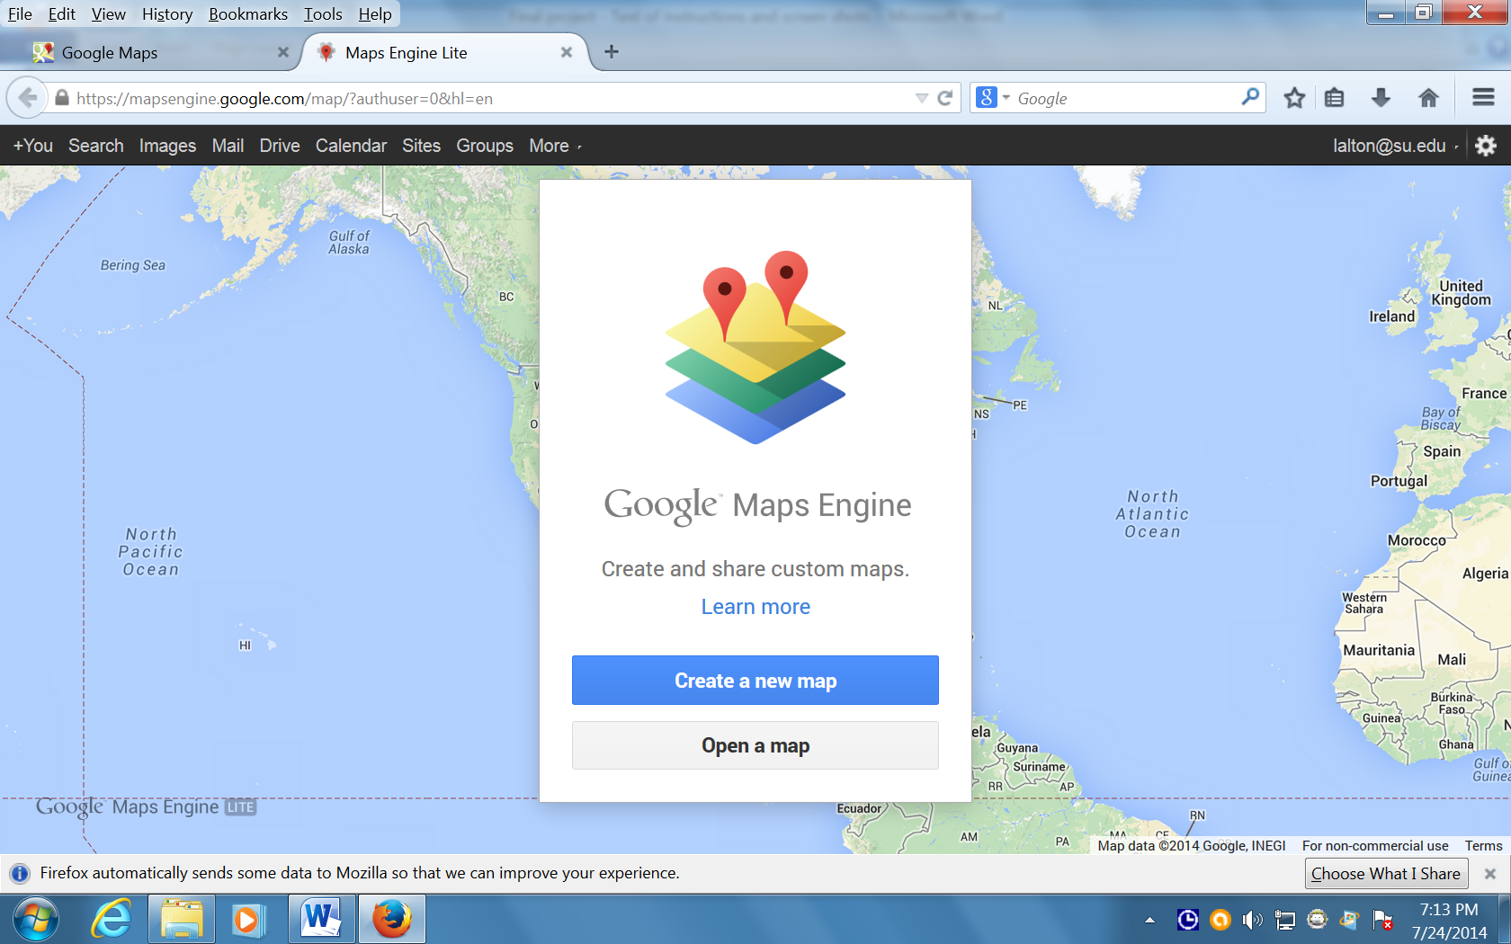

To make a new map click on “Create a new map”.

To edit an old map of yours, click on “Open a map”.

On the screen that appears, click on “Untitled map” in the upper left-hand corner, and give your map a name. You can also add a description of your map.

Use the search bar in the map to find the city or region that you want to include in your map.

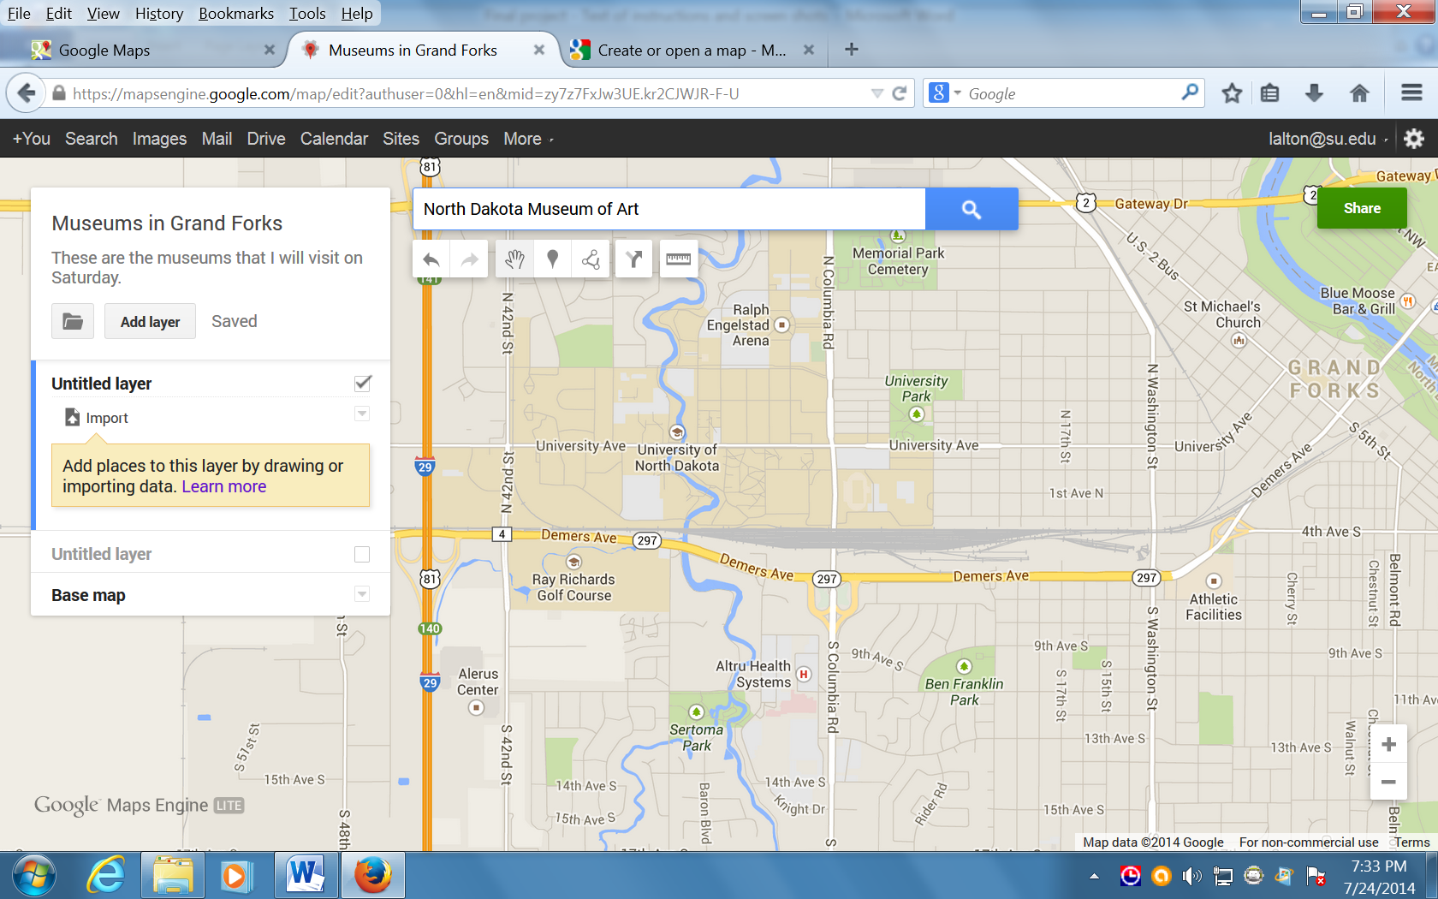

This is a map of Grand Forks, North Dakota. I want to visit the North Dakota Museum of Art, and I have typed the name of that museum into the search bar.

I can zoom in, or zoom out using the + and – signs in the lower right-hand corner of the map.

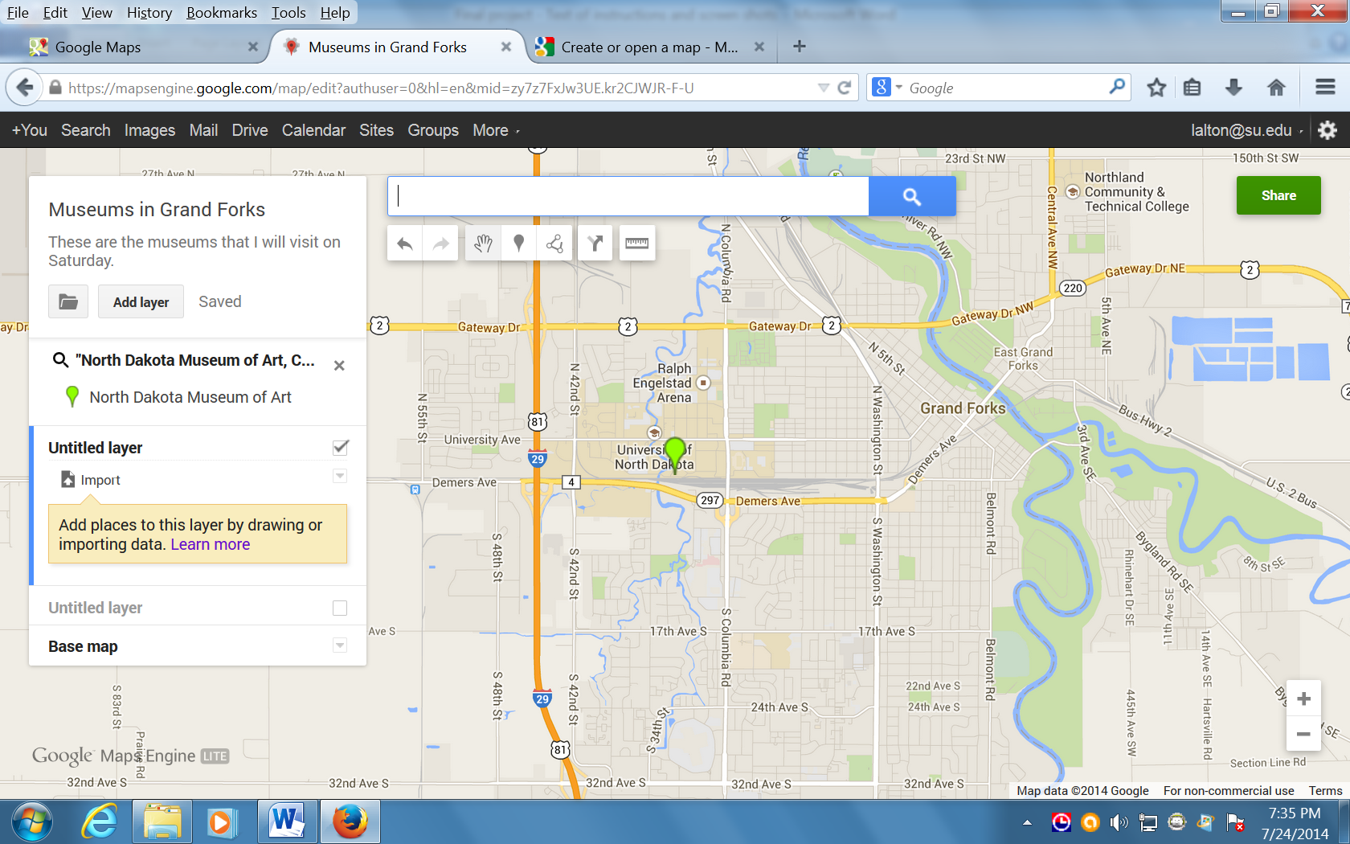

When I click on the search magnifying glass at the end of the search bar, the map shows where this museum is located in the city.

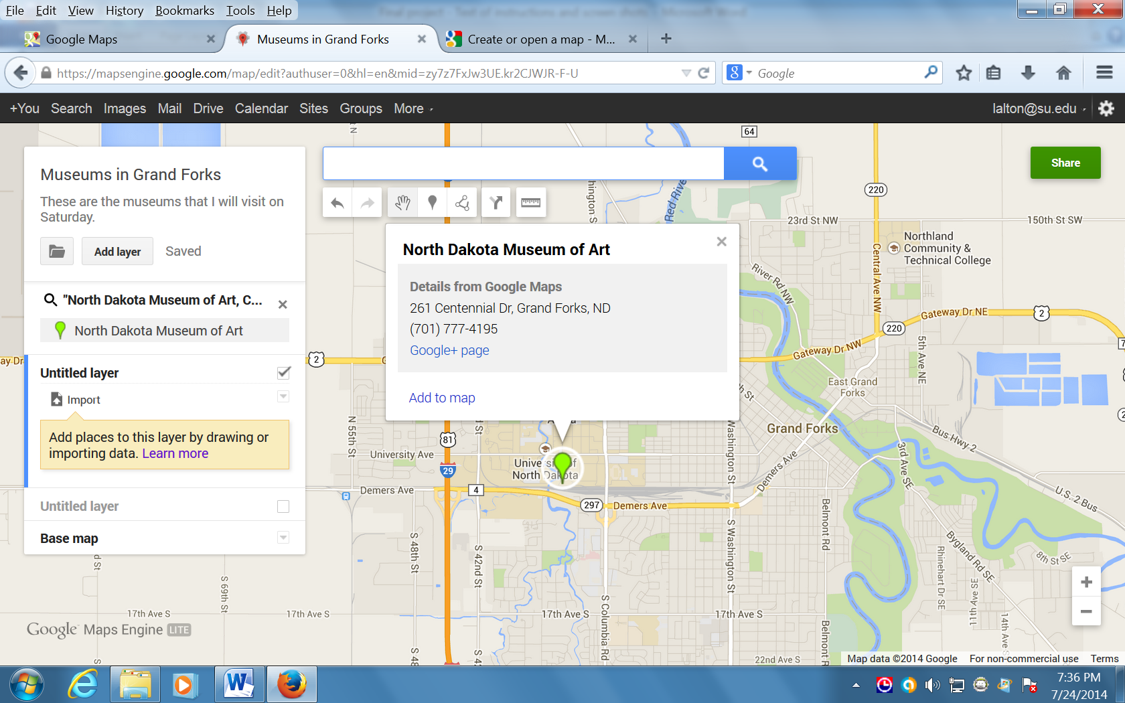

When I click on the marker, a window opens asking if I want to add it to my map. After I click on “Add to map”, the marker changes color, showing that it is part of my custom map now.

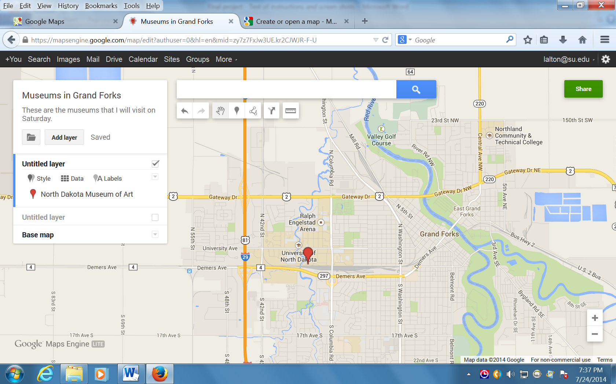

I’m going to search for the Hughes Fine Arts Center at the University of North Dakota.

After I search for it with the search bar, I will add it to the map.

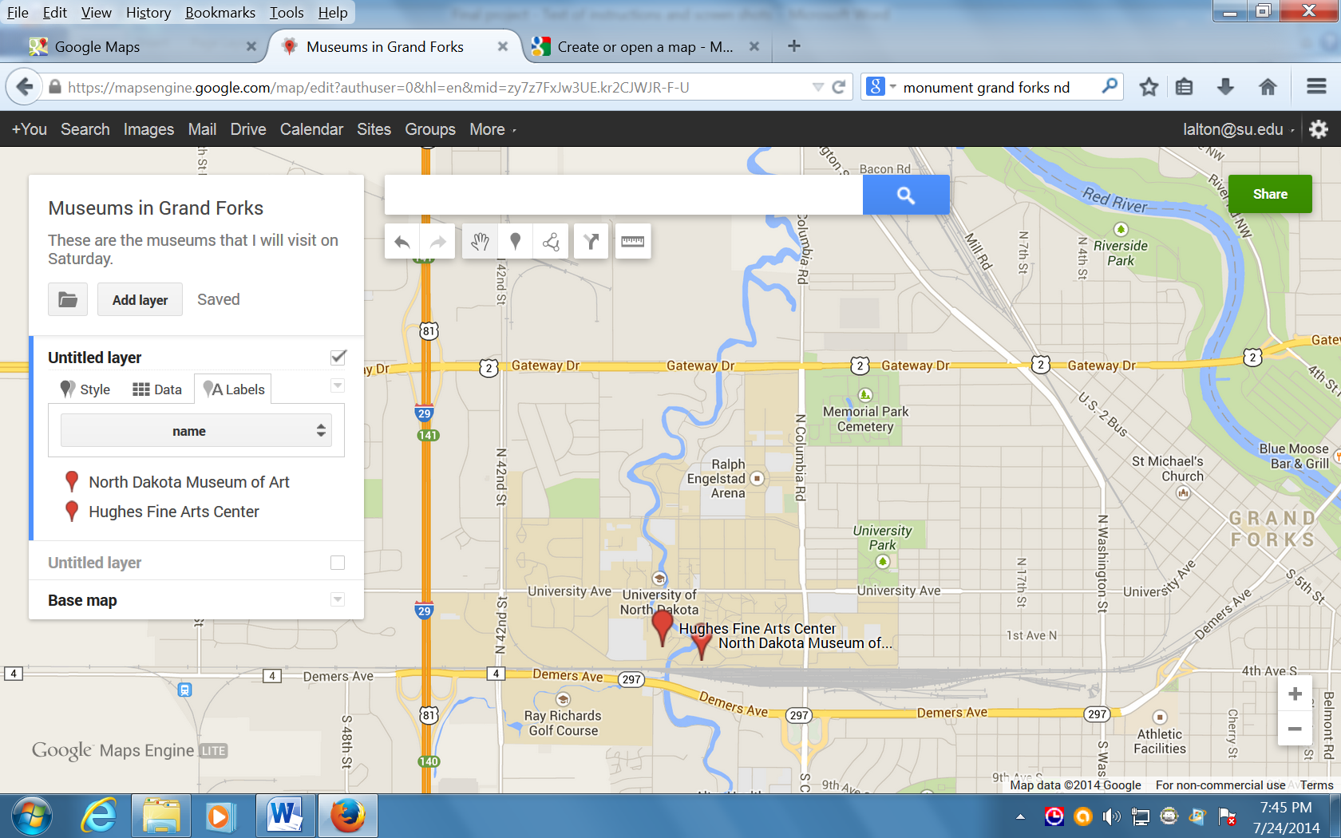

I can add the names of these museums by clicking on the word “Labels” in the box on the left that has the name of my map.

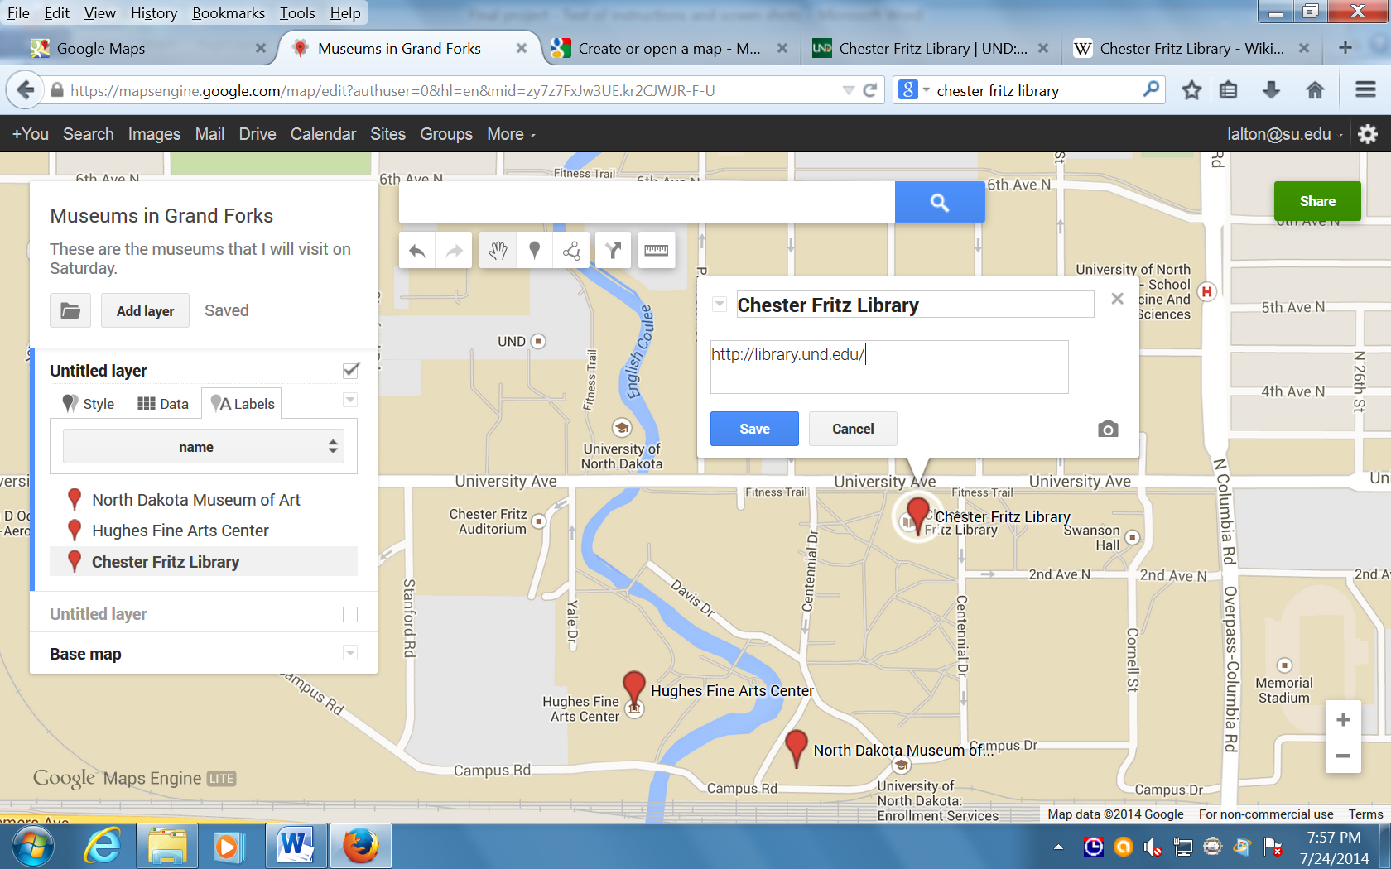

There are several symbols under the search bar. The teardrop one will let you add a marker any place you like.

When you click on the add marker sign, the cursor turns into a + sign that you can move around the screen. Click again to place the marker where you want it.

For each marker, you can include a name and a description, photo, or a link to a website, or YouTube video.

To edit information about a location, click on that location’s marker, or on the location’s name in the list on the left of the screen.

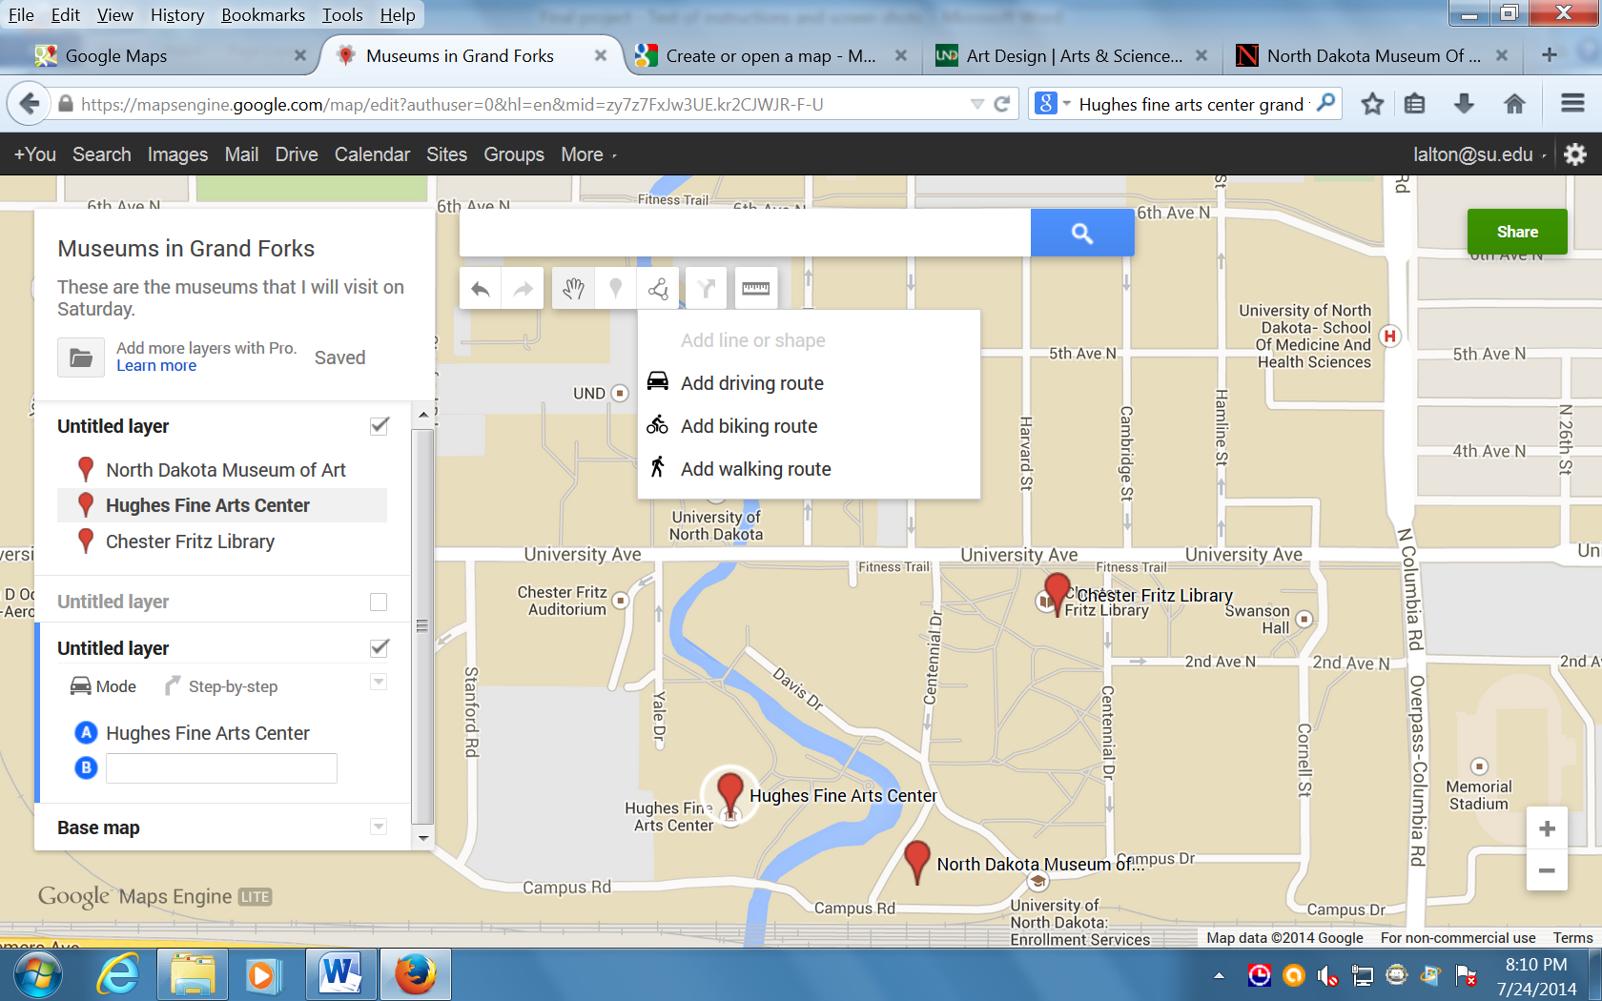

To add a driving, biking, or walking route, click on the symbo underneath the search bar that has three circles connected by lines.

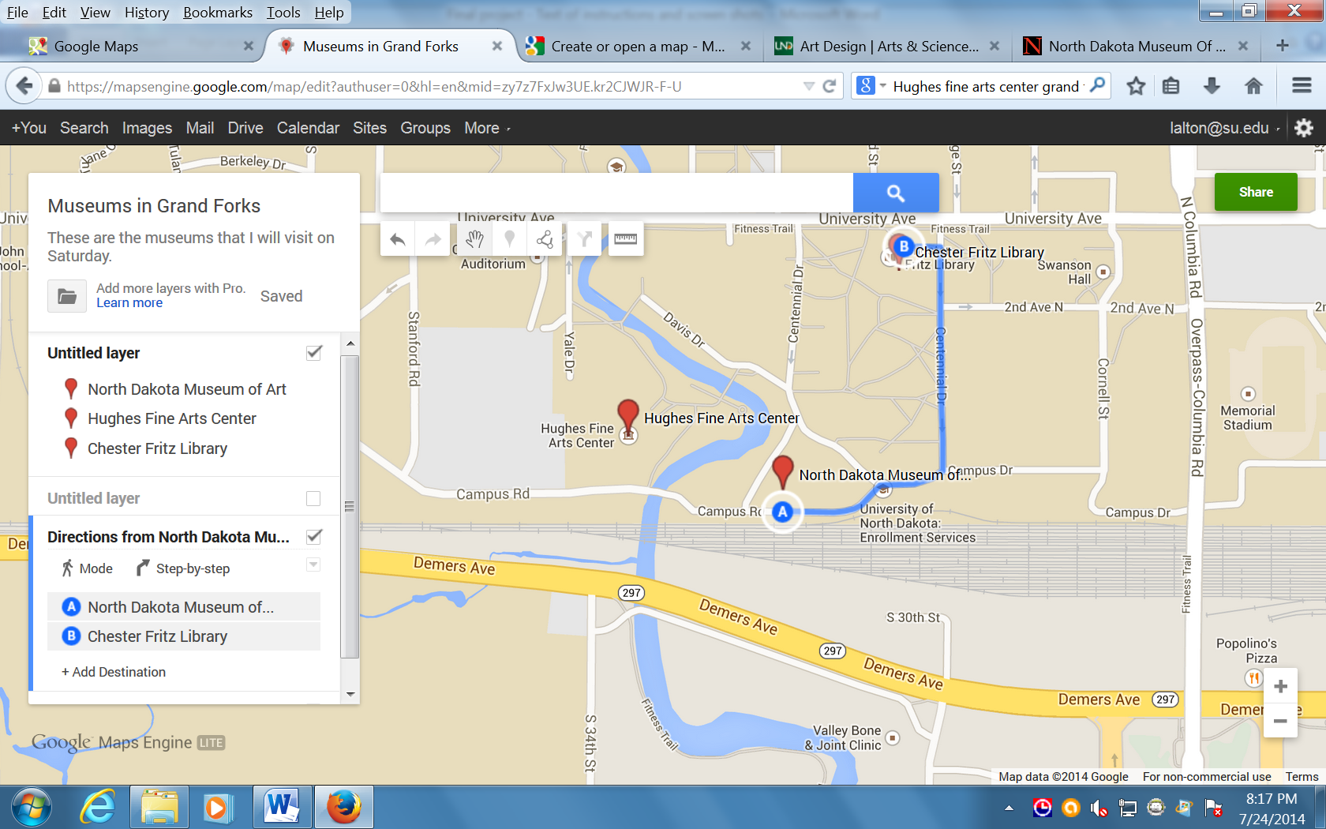

Click where you want to start your walk and move your curser to where you want your walk to end. Your cursor will turn into a + sign.

Do not drag your cursor, just move it over the map.
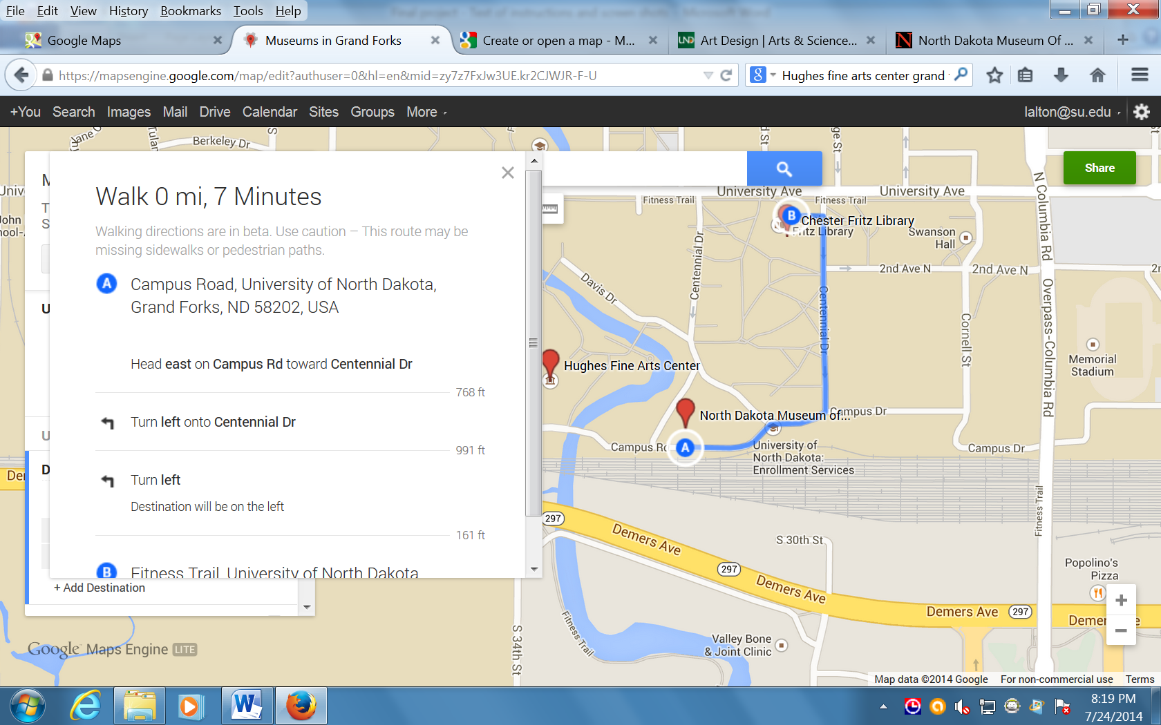

You can ask Google to tell you how long the walk is and how much time it will take.

Google will also give you turn-by-turn directions. You can copy and paste the directions into your Google Doc and edit so that you have the detailed description of your walking route.

To save and share your route, click on the “Share” button in the upper right-hand of the screen.
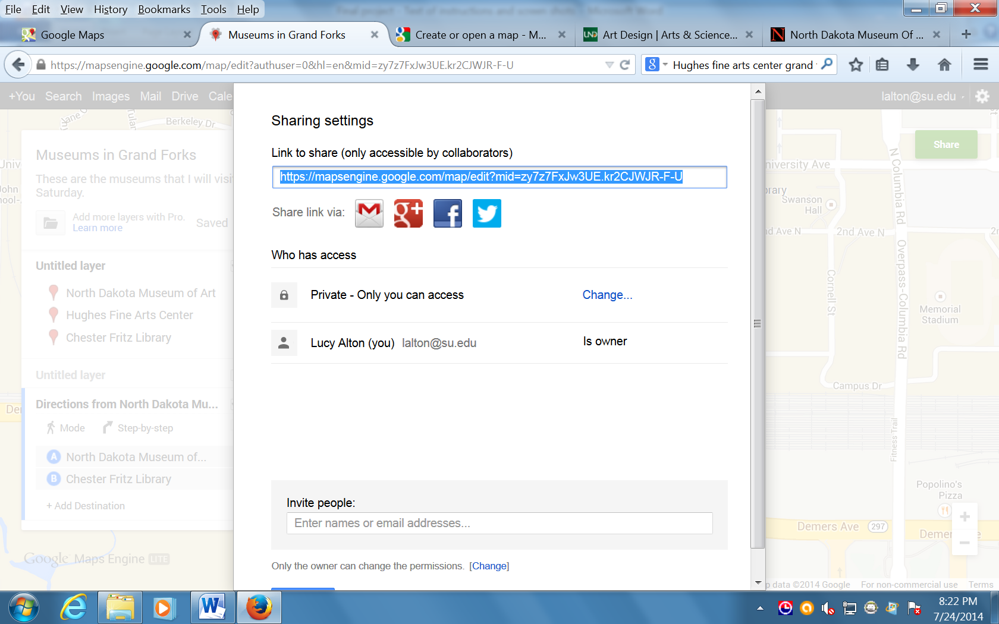

This window lets you decide who can see my map. You will need to share your map with everyone on your team. You also will need to allow the members of your team to be able to edit your map, just like you allow them to edit your shared Google Docs.

Now you have an idea how to start your map. Have fun making your map!

